Group visits
Restored to its Edwardian Arts and Craft splendour, Winterbourne House is a unique heritage attraction – set within seven acres of beautiful botanic gardens. Only minutes from Birmingham city centre, Winterbourne is a hidden gem – home to beautiful antiques and over 6,000 plant species from around the world. Wander along the woodland walk, stroll through the hazelnut tunnel, cross the 1930’s Japanese Bridge or simply soak up the tranquillity of this perfectly English Edwardian home.
Winterbourne is a perfect venue to visit with a group. We only welcome up to 2 Groups per day, ensuring that you can enjoy the very best experience of the house and garden.
We offer two group visit options; both require a minimum of 15 visitors and have a maximum of 53:
Clematis  ■ Meet and greet  ■ House and garden admission for the group  ■ Garden tour  £15.00 per person* |  | Honeysuckle  ■ Meet and greet  ■ House and garden admission for the group  £8.00 per person*
*£60 deposit required.

Opening times
November – February: 10.30am to 4pm.
March – October: 10.30am – 5pm.
Group visits are available Monday to Friday (excluding Bank Holidays)

Booking a group visit
To ensure that your visit to Winterbourne goes as smoothly as possible please first check availability with us. Please also note the following:
■ To be eligible for the group admission price your group must have a minimum of 15 paying individuals, and you must pre-book your visit a minimum of 14 days in advance*. Payment must be made by one person
■ The group leader and coach driver (if applicable) enjoy free admission
■ Concessions such as RHS Membership and other voucher offers are not valid for those attending with a Group Visit
■ We operate a maximum of 53 people per group
■ A deposit of £60 is required to confirm your booking
■ Pre-booked catering is available on request from May to September for groups of 25 or more

*Final numbers for any visit that includes pre-booked catering must be confirmed at least twenty-five days before your visit. Payment must also be made for the catering at this point and is non-refundable.

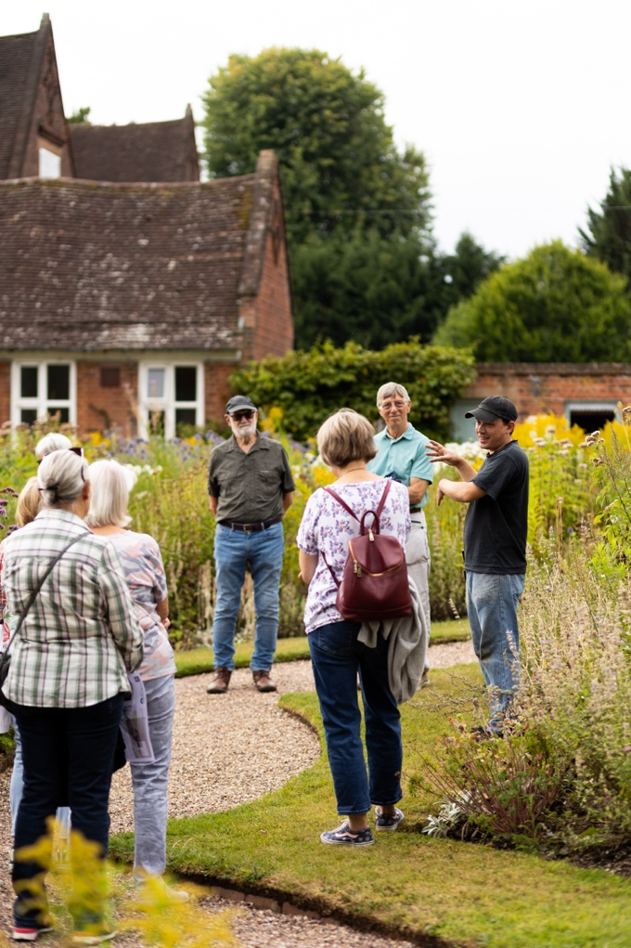
Tours
Our Clematis package includes a tour with one of our gardeners. A tour takes visitors to all corners of the garden and provides the opportunity to delve into over 100 years of history, our diverse variety of plants, how we care for it today and our plans for the future. Large groups will be split into two to ensure the best possible experience and opportunity for interaction.
If booking a tour, please advise us of any mobility issues so the tour may be tailored to your needs.
Please note that due to the size of the rooms we do not offer guided tours of the house.

Pre-booked catering
■ Selection of sandwiches (one round per person)
■ Fruit scone, clotted cream and preserves
■ Freshly brewed tea and coffee, still and sparkling water
£14.50 per person
Catering
Catering at Winterbourne is looked after by the University of Birmingham’s ‘Food Fellows’. The Terrace Tea Room is open from 10.30am and last service is 30 minutes before Winterbourne closes. We ask groups using the tearoom to stagger their lunches to help reduce queues.
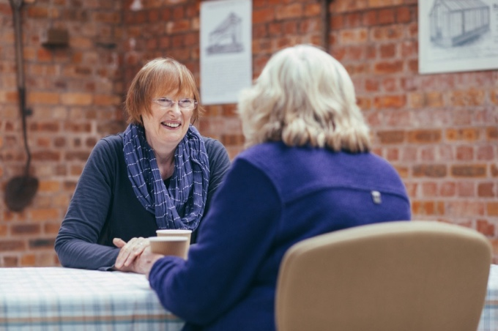
A pre-booked catering option is available for groups of 25 people or more from May to September, with seating in our ‘Old Tool Shed’*.
Confirmation of numbers, final dietary requirements and payment in full are required 25 days prior to the visit. Maximum capacity is 53 people.
Payment methods
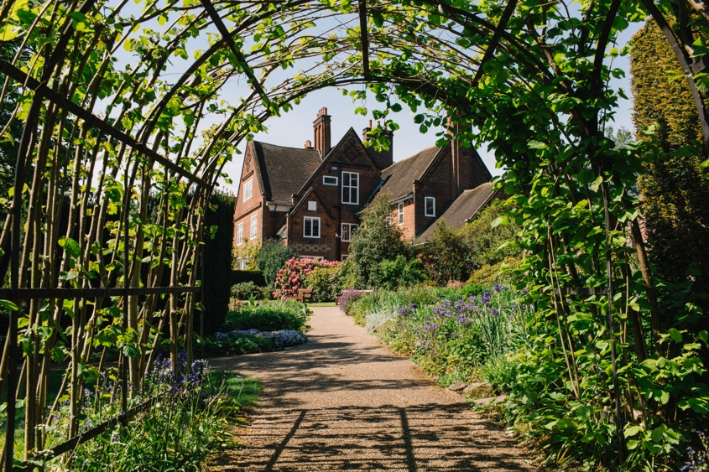
To confirm your booking and reserve your date we require receipt of a completed booking form, either by post or email, and a deposit of £60. Payment can be made via our online payment portal, instructions for which are to be found on the booking form. Alternatively, if you are unable to use the portal, you may return your form by post and enclose a cheque.
The remaining admission/tour balance will be invoiced prior to your visit for payment via the portal. If you wish to pay by cheque via post, or by card/cheque on arrival please inform our Booking Team.
Cheques should be made payable to ‘The University of Birmingham’.
Winterbourne House and Garden, University of Birmingham,
58 Edgbaston Park Road, Birmingham, B15 2RT
Group booking form
Unique Booking Reference | As you do not yet have a Unique Booking Reference, please contact us to confirm the date of your booking so we can provide the number.
Name of group
Proposed date of visit
Proposed time of
arrival / departure
Number in group
Method of transport
(coach / cars etc.)

Group organiser details
Name
Address
Email address
Phone number
Alternative contact
name and number

Chosen package | Clematis (including garden tour) Honeysuckle
Tour time (if applicable) | 11.15am 2.00pm
Accessibility requirements
(if applicable)
Pre-booked catering time (if applicable,  May – September only) Payment required 25 days prior to visit. | 12.00pm 12.30pm 1.00pm 1.30pm 2.00pm
Dietary requirements
(if applicable) Final details to be confirmed 25 days prior to visit.

When choosing a time for your Garden tour we advise to allow minimum of 45 minutes after arrival, for your group to visit the facilities and also get a drink from the tearoom should they wish. Please advise us of any accessibility requirements in the above box, we ask for this information so that we can plan your tour with this in mind, as some of the routes are not fully accessible.
Contact details collected on this form will be used in connection to your group visit to us and are only kept on file for one calendar year following your visit.
Payment
A non-refundable deposit of £60 is required to secure your date and confirm the booking.
Deposit amount | £60 (non-refundable)
Payment method

Online Payment Portal

Date submitted _______________________

Cheque enclosed (payable to ‘The University of Birmingham’) - (minimum) 14 days prior to visit

Normal method of payment is via our online payment portal, instructions for which can be found below.
Please note you will require your Unique Booking Reference, found at the top of the Booking Form, to complete this payment.
If you have not already confirmed the date of your booking with us, please do so by returning your Booking Form so that we can confirm availability and provide you with your Unique Booking Reference allowing you to make payment.

I confirm that all the details I have provided are correct and I understand that any changes must be notified to Winterbourne a minimum of 14 days before the visit:
Signature: Date:

Online Payment 
Payment can be made via our online portal https://epay.bham.ac.uk/winterbournegroups
When forwarded to the payment section you will be transferred to the University of Birmingham’s online payment provider, Flywire.
Please follow the instructions on the screen. You may pay by card or via Bank Transfer.
If paying by Bank Transfer you will need to note down Flywire’s payment reference to utilise as reference when processing the transfer from your Bank Account. Please do not use your Booking reference.
Should you have any queries please call our Group Bookings Department on 0121 414 9113.
The office number can be busy, so do please leave a message if your telephone call is not answered and we will get back to you as soon as possible.

Completed booking form to be emailed to:
 winterbourne@contacts.bham.ac.uk
Or a hard copy posted to: Group Bookings, Winterbourne House and Garden, University of Birmingham, 58 Edgbaston Park Road, Edgbaston, Birmingham B15 2RT.

Additional information
Parking: We have a car park adjacent to the main drive, which has around 40 spaces, along with limited spaces next to the house including three blue badge parking spaces. Coaches can drop off at Winterbourne and then need to park at the North Gate of the University Campus – a map will be provided on arrival. Please note that the driveway to Winterbourne is quite small and coach drivers may find it easier to reverse down it, as is not possible to turn around. Due to health and safety regulations staff members are unable to help reverse on to the busy road.
Access: Every effort is made to ensure that our visitors with disabilities are able to enjoy their visit to Winterbourne. Most areas of the garden are accessible by wheelchair and those with walking difficulties may borrow one of the mobility scooters for garden use. Use of the scooters is subject to availability and although we cannot guarantee to reserve them, please notify us if you plan to use one. There is a lift to both floors of the house and an accessible toilet near the house reception.
Storage/cloakroom: Unfortunately, we are unable to provide storage for bags/coats etc., please ensure anything you will not be using is left in your vehicle/coach as we are unable to store it for you.
Suitable clothing: Please ensure all members of your party wear appropriate clothing/footwear as there are uneven surfaces in the garden and the weather can never be guaranteed.
Directions by road: Follow signposts for University of Birmingham, nearer campus follow signs for Winterbourne House and Garden or enter B15 2RT into Satnav systems.
Directions by rail: The nearest station is University, for train times see www.nationalrail.co.uk. The quickest way to us from the train is to take a left outside station, cut straight through the campus following signposts for The Barber Institute. Then take a left-up Edgbaston Park Road when you reach the Barber Institute. You will find us next to King Edwards Girls School.
Directions by bus: The X21 and X22 National Express bus services stop along Edgbaston Park Road. Buses are also available to the A38 Bristol Road from the city centre. For bus times see www.nxbus.co.uk.

