Group Visits
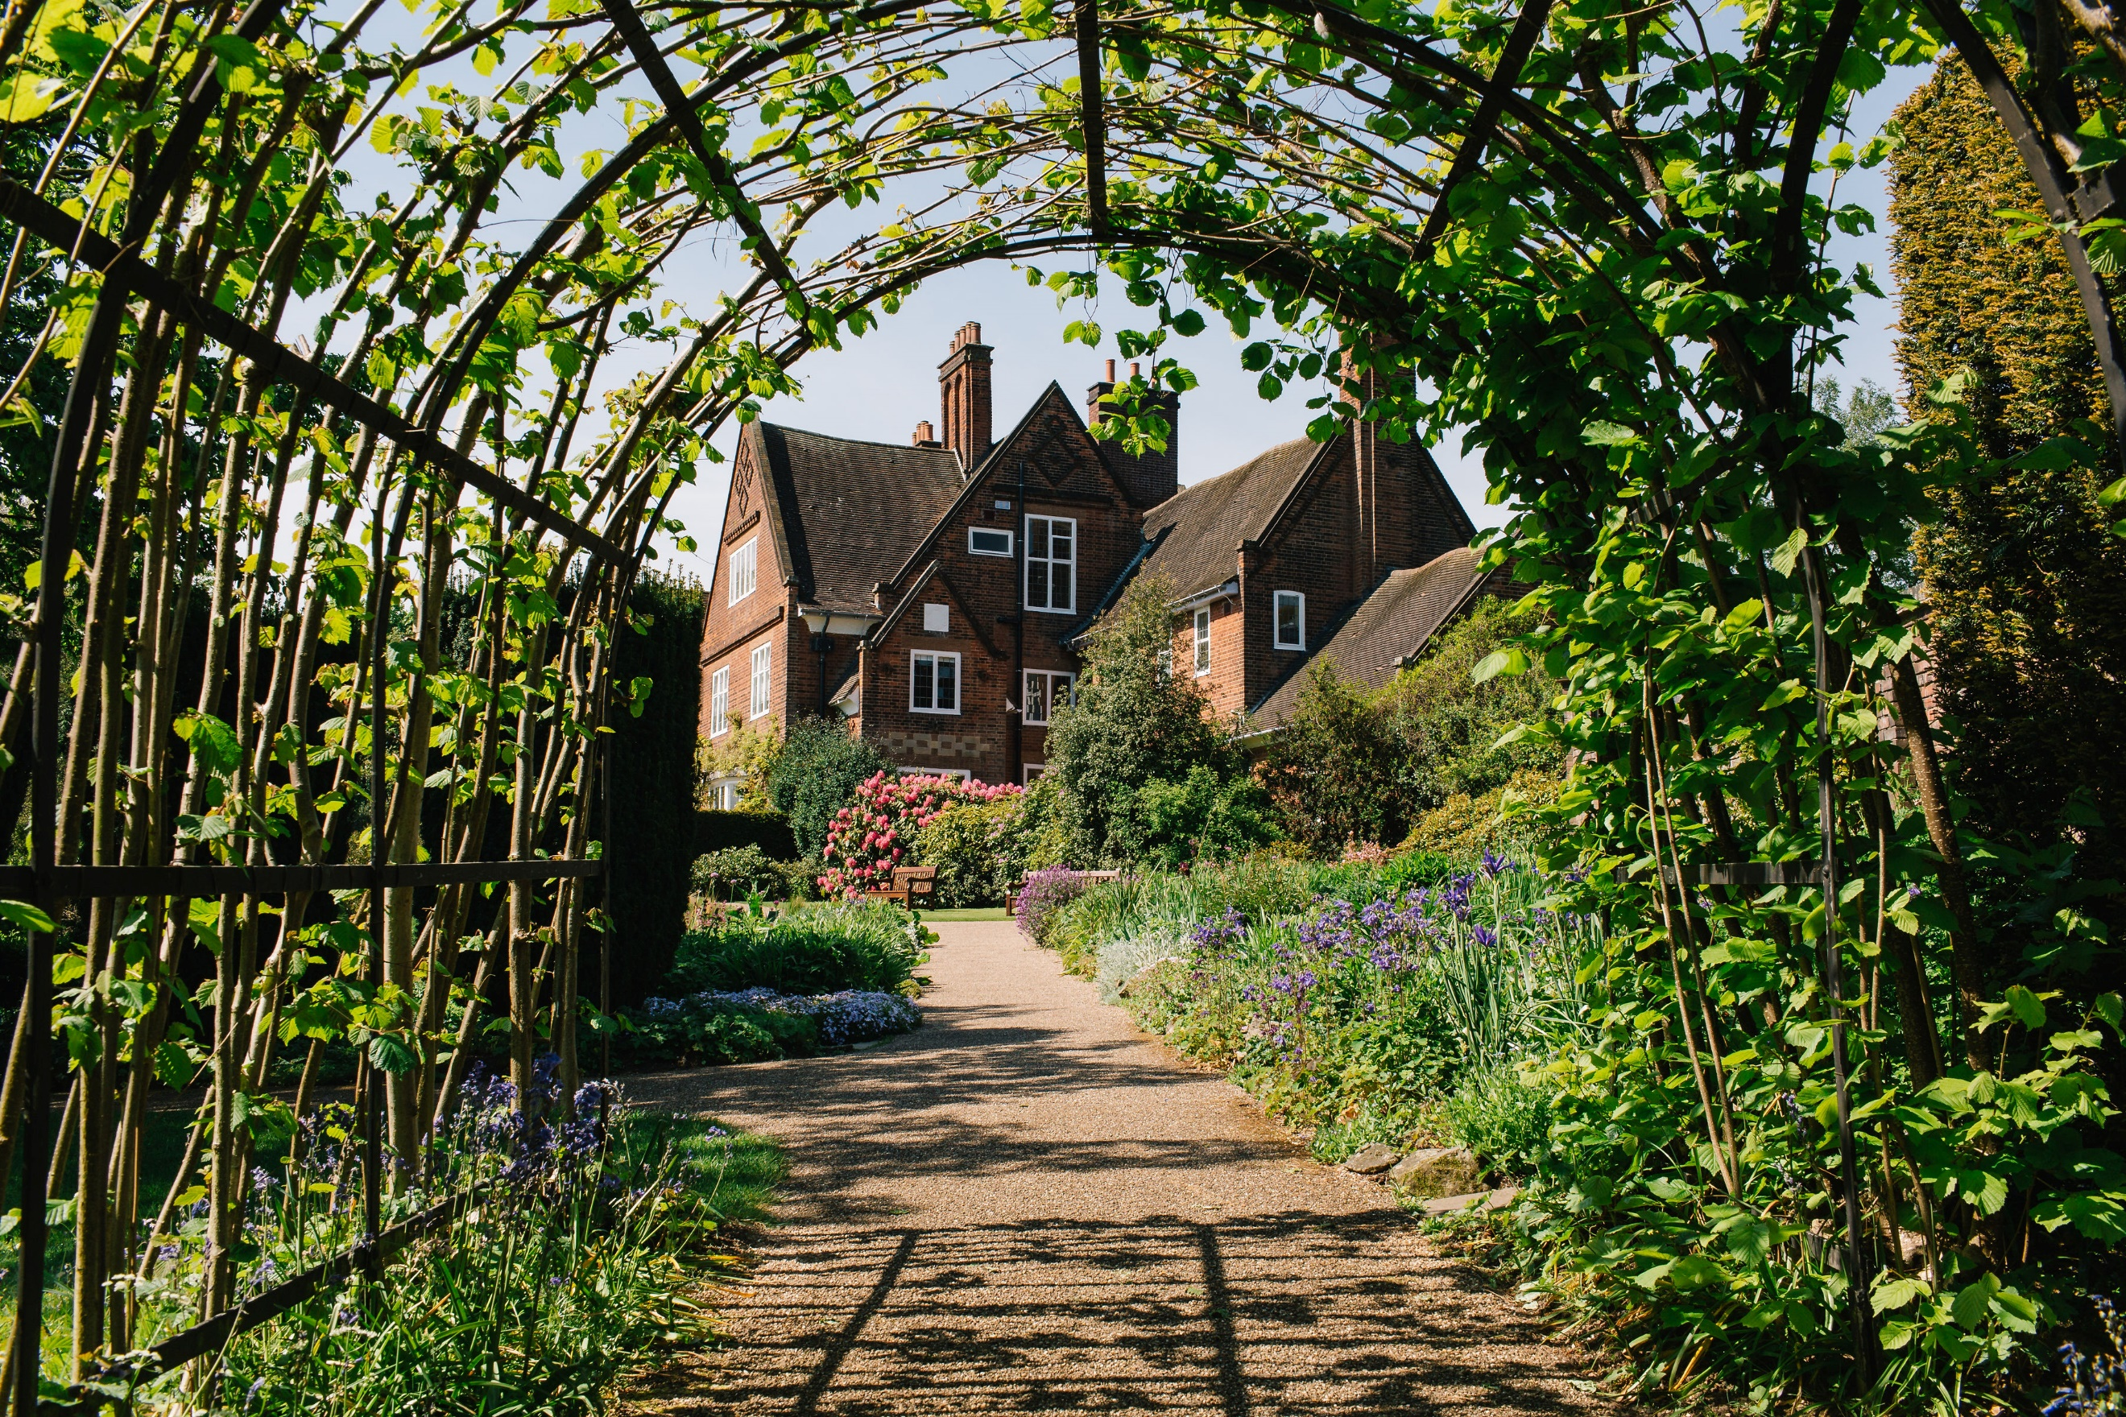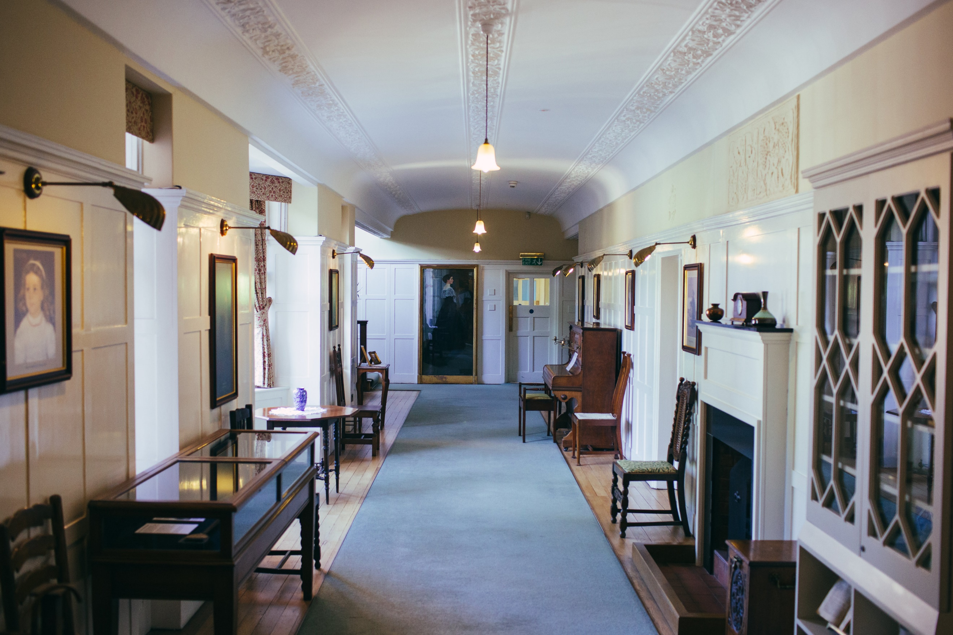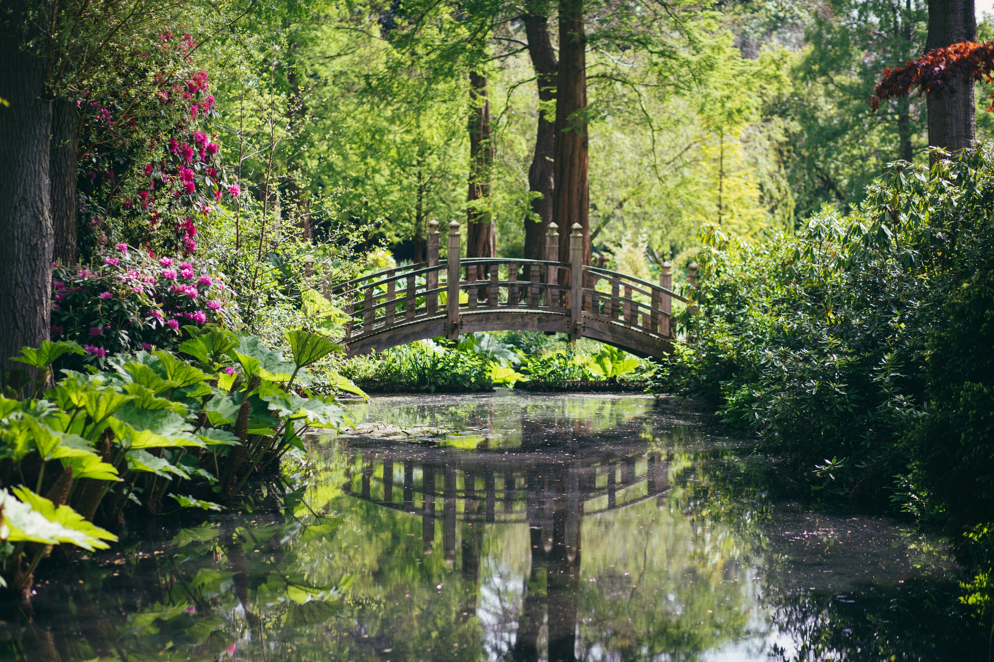
Restored to its Edwardian Arts and Craft splendour, Winterbourne House is a unique heritage attraction – set within seven acres of beautiful botanic gardens. Only minutes from Birmingham city centre, Winterbourne is a hidden gem – home to beautiful antiques and over 6,000 plant species from around the world. Wander along the woodland walk, stroll through the hazelnut tunnel, cross the 1930’s Japanese Bridge or simply soak up the tranquillity of this perfectly English Edwardian home.
Opening Times
November – February: 10.30am to 4pm. March – October: 10.30am – 5pm.
Group visits are available Monday to Friday (excluding Bank Holidays)

Winterbourne is a perfect venue to visit with a group. We only welcome up to 2 Groups per day, ensuring that you can enjoy the very best experience of the house and garden. We offer two Group visit options; both require a minimum of 15 visitors and have a maximum of 53:
CLEMATIS | HONEYSUCKLE
- Meet and greet.  - House and Garden admission for the group  - Garden tour | - Meet and greet.  - House and Garden admission for the group
£12.50 per person | £6.50 per person
£60 deposit required
Booking a Group Visit
To ensure that your visit to Winterbourne goes as smoothly as possible please first check availability with us. Please also note the following:
- To be eligible for the Group admission price your group must have a minimum of 15 paying individuals, and you must pre-book your visit a minimum of 14 days in advance*. Payment must be made by one person.
- The group leader and coach driver (if applicable) enjoy free admission.
- Concessions such as RHS Membership and other voucher offers are not valid for those attending with a Group Visit.
- We operate a maximum of 53 people per group.
- A deposit of £60 is required to confirm your booking.
- *Final numbers for any visit that includes pre-booked catering must be confirmed at least twenty five days before your visit. Payment must also be made for the catering at this point and is non-refundable.
Tours
Our Clematis package includes a tour with one of our gardeners. A tour takes visitors to all corners of the garden and provides the opportunity to delve into over 100 years of history, our diverse variety of plants, how we care for it today and our plans for the future. Large groups will be split into two to ensure the best possible experience and opportunity for interaction.
If booking a tour, please advise us of any mobility issues so the tour may be tailored to your needs.

Catering
Catering at Winterbourne is looked after by the University of Birmingham’s ‘Food Fellows’.

The Terrace Tea Room is open from 10.30am and last service is 30 minutes before Winterbourne closes. We ask groups using the tearoom to stagger their lunches to help reduce queues.

A pre booked catering option is available with from May to September, with seating in our ‘Old Tool Shed’. Confirmation of numbers and payment in full is required 25 days prior to the visit.

Selection of Sandwiches (1 round per person)

Fruit scone, clotted cream, and preserves

Freshly brewed tea and coffee
£13.95 per head

Payment Methods
A deposit of £60 must be paid with your completed form to confirm your booking and reserve your date. You can enclose a cheque with your booking if posted or a member of the team will call when your form is received to process payment via credit or debit card.
The remaining entrance/tour balance can be paid by card or cheque prior to the visit or on arrival.
Cheques should be made payable to ‘The University of Birmingham’.
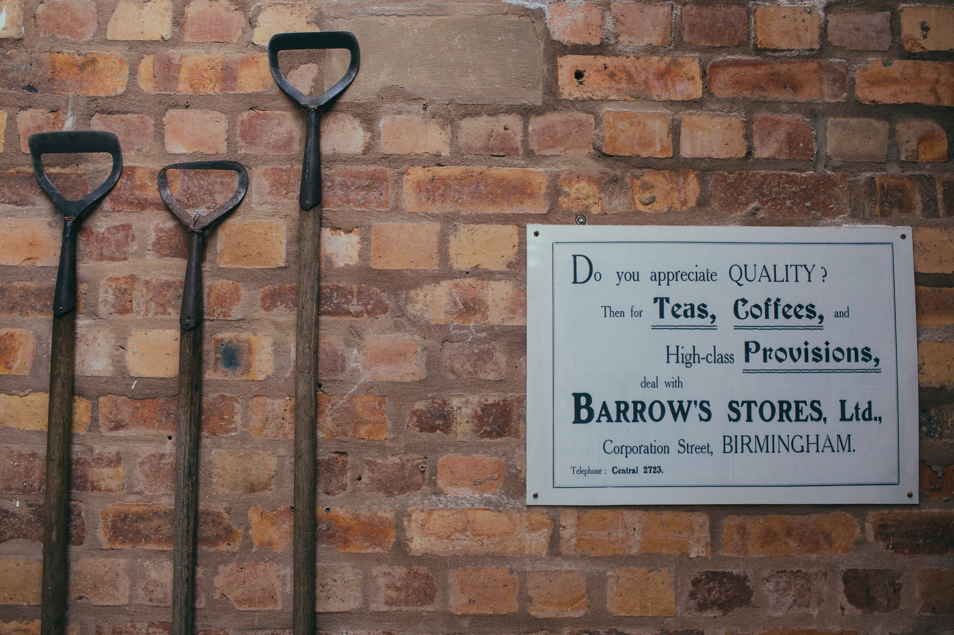
Winterbourne House and Garden
University of Birmingham
58 Edgbaston Park Road
Birmingham
B15 2RT

Group Booking Form
Name of group
Proposed date of visit
Proposed time of arrival / departure
Number in group
Method of transport (coach/cars etc.,)

Name of group organiser
Address of group organiser
Email address of group organiser
Organiser mobile phone number
Alternative contact name and number

Chosen package | Clematis  (inc., Garden tour) |  |  | Honeysuckle
Tour time, if applicable (please circle) | 11.15 / 14.00
Pre booked catering time, if applicable (please circle) (May to September only) | 12.00 | 12.30 | 13.00 |  | 13.30 | 14.00
Dietary requirements, if applicable:

Accessibility requirements, if applicable:

When choosing a time for your Garden tour we advise to allow a minimum of 45 minutes after arrival, for your group to visit the facilities and also get a drink from the tearoom should they wish. Please advise us of any accessibility requirements in the above box, we ask for this information so that we can plan your tour with this in mind, as some of the routes are not fully accessible.
Contact details collected on this form will be used in connection to your group visit to us and are only kept on file for one calendar year following your visit.

Payment (circle as applicable)
Deposit | £60 | Cheque enclosed |  | Cheque/card (minimum) 14 days prior to visit
Balance* | Amount  £ _____:_____ | Cheque enclosed | Cheque/card prior to visit |  | Cheque/card on arrival

*Balance due 25 days in advance for pre-booked catering

I confirm that all the details I have provided are correct and I understand that any changes must be notified to Winterbourne before arrival: Signed ______________________ Date _________________________

Completed booking form to be emailed to: winterbourne@contacts.bham.ac.uk
or a hard copy posted to:
Group Bookings, Winterbourne House and Garden, University of Birmingham, 58 Edgbaston Park Road, Edgbaston, Birmingham B15 2RT.
Tel: 0121 414 4414
The Box Office number can be busy, so do please leave a message if your telephone call is not answered.

Additional Information
Parking: We have a car park adjacent to the main drive, which has around 40 spaces, along with limited spaces next to the house including three blue badge parking spaces. Coaches can drop off at Winterbourne and then need to park at the North Gate of the University Campus – a map will be provided on arrival. Please note that the driveway to Winterbourne is quite small and coach drivers may find it easier to reverse down it, as is not possible to turn around. Due to health and safety regulations staff members are unable to help reverse on to the busy road.
Access: Every effort is made to ensure that our visitors with disabilities are able to enjoy their visit to Winterbourne. Most areas of the garden are accessible by wheelchair and those with walking difficulties may borrow one of the mobility scooters for garden use. Use of the scooters is subject to availability and although we cannot guarantee to reserve them, please notify us if you plan to use one. There is a lift to both floors of the house and an accessible toilet near the house reception.
Storage/cloakroom: Unfortunately, we are unable to provide storage for bags/coats etc., please ensure anything you will not be using is left in your vehicle/coach as we are unable to store it for you.
Suitable clothing: Please ensure all members of your party wear appropriate clothing/footwear as there are uneven surfaces in the garden and the weather can never be guaranteed.
Directions by road: Follow signposts for University of Birmingham, nearer campus follow signs for Winterbourne House and Garden or enter B15 2RT into Satnav systems.
Directions by rail: The nearest station is University, for train times see www.nationrail.co.uk. The quickest way to us from the train is to take a left outside station, cut straight through the campus following signposts for The Barber Institute. Then take a left-up Edgbaston Park Road when you reach the Barber Institute. You will find us next to King Edwards Girls School.
Directions by bus: The X21 and X22 National Express bus services stop along Edgbaston Park Road. Buses are also available to the A38 Bristol Road from the city centre. For bus times see www.nxbus.co.uk.

