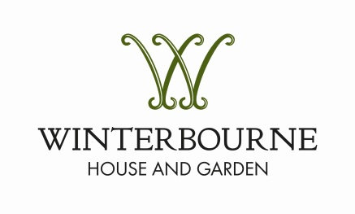
Donation of Objects

What does Winterbourne collect?

Winterbourne House and Garden actively collects items which fall within the following categories:
- Items that were owned by, or are linked to, the Nettlefold, Wheelock or Nicolson families;
- Late Victorian and early Edwardian household objects that reflect the lifestyle of a middle class family or their servants in the early 20th century;
- Items that are linked to the Arts and Crafts movement;
- Archival materials that were owned by, or are linked to, the Nettlefold, Wheelock or Nicolson families;
- Archival materials or objects relating to the house and garden after the property was bequeathed to the University of Birmingham in 1944;
- Objects relating to the history of letterpress printing.

How are potential acquisitions assessed?
All potential acquisitions should be referred in the first instance to the Collections Officer. When deciding whether the object should be acquired, the Collections Officer will take various factors into account, including:
- Does the object fulfil at least one of the collecting priorities set out above?
- Is the object duplicated within the existing collection?
- Is the object being offered as a gift, bequest, purchase or loan?
- Is the object in good condition?
- How might the object be used (e.g. for display, for handling, for educational or research purposes)?
- What are the costs, if any, associated with the acquisition?
- Are there any terms and conditions attached to the acquisition?
- How did the donor come to own the object, and do they have the sole authority to donate it?

In order to assess a potential acquisition, the Collections Officer will need to view the object, either at Winterbourne (if the donor is able to bring it in) or at the donor’s home. If the donor lives at a distance, it may be possible for the Collections Officer to make a decision on the basis of a photograph.

What happens next?

Once the object has been assessed, the Collections Officer, in consultation with the Head of Winterbourne, will make a decision as to whether to accept the object for the collection. Normally this process should take a few days at most. If the acquisition is confirmed, the donor will be asked to sign a ‘Donation Form’ confirming the transfer of ownership of the object to Winterbourne.

An object being offered on loan to Winterbourne will be subject to a similar approval process. A fixed time period will be agreed for the loan, at the end of which the object will be returned to its owner, or, if appropriate, the loan will be renewed for a further fixed term.

In some circumstances, for instance if the object is in poor condition or is duplicated within the existing collection, or if the object does not fulfil one of Winterbourne’s collecting priorities, the proposed donation may be declined. Alternatively, the Collections Officer may suggest that the object should be acquired for the ‘handling’ collection. Handling objects may be used for educational purposes or for ‘set dressing’, and therefore they are at risk of being damaged. Objects will only be accepted on this basis with the full consent of the donor.

If you would like to offer an object to Winterbourne, please contact:

Henrietta Lockhart
Collections Officer
0121 414 8628 (Mondays, Tuesdays and Wednesday mornings)
h.c.j.lockhart@bham.ac.uk

